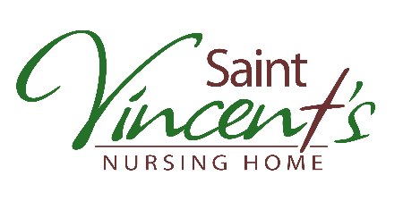
January 08, 2021

Dear Residents and Family Members & Friends,
Today the Public Health Order was updated to allow the continuation of indoor visiting. These visits, in the Windsor Room, are weekdays between 1 pm and 4 pm for up to two people visiting at a time. We assigned each unit to a specific day for visiting (Monday-2nd, Tuesday, 3rd, Wednesday – 4th, Thursday – 5th, Friday – 6th. Please speak with Kathy to book an appointment or if you need to make alternative arrangements.
Unscheduled designated caregiver visits are working well. If you have not visited before and are a designated caregiver, you must book the first visit to allow for the necessary training. Otherwise, please continue to visit at your convenience, one caregiver at a time (with only two total caregivers per resident).
Thank-you to the caregivers for adhering to the requirement to stay in the resident’s room. I know this is challenging and am very appreciative of the effort. In addition, we are pleased that masks are being consistently worn in the building and while visiting.
We have been asked about being able to bring in coffee or a snack when visiting. Although, the caregiver must keep their mask on for the entire visit, if you want to bring in a special meal or treat for the resident, please feel free. Perishable items cannot be stored in the room or the fridge (as per infection control requirements) so it must be consumed during the visit or taken with you when you leave. If you are unsure about dietary restrictions, please check with staff before providing any food or drink.
In addition, we are resuming scenic drives. Designated caregivers must book the pick-up time to ensure the resident is ready.
Starting Monday, you will notice work beginning on the exterior doors which are all being replaced including the entire vestibule. You will still access the building through the vestibule using the north side sliding door. During construction items cannot be left; instead, please knock and wait for someone to come and get the items from you. Please do not enter the facility if you are not visiting. Drop-off will be restricted to between 9 am and 5 pm.
COVID-19 Updates are available via:
- Saint Vincent’s Facebook Page: @Snares
- Saint Vincent’s website: SVNH.ca
- Calling our information line 24 hours a day: 902-334-1444
- If you wish to be added to our regular email list, send your email address to nmaguire@svnh.ca

